**Name**: Adwait Purao

**UID**: 2021300101

**Batch**: D

**Aim**:

Design Interactive Dashboards and Storytelling using using D3.js / Power BI / R / Python / D3.js on the dataset - Environment / Forest cover

* Basic - Bar chart, Pie chart, Histogram, Time line chart, Scatter plot, Bubble plot
* Advanced - Word chart, Box and whisker plot, Violin plot, Regression plot (linear and nonlinear), 3D chart, Jitter
* Write observations from each chart

Theory:

**Dataset**:

<https://www.kaggle.com/datasets/adwaitpurao/indian-forest-fires-comprehensive-dataset>

**Dataset Overview:**

This dataset, titled "Annual Change in Forest Area", captures global forest conversion trends across various countries over different time periods. It contains data spanning the years 1990, 2000, 2010, and 2015, providing insights into how forest areas have expanded or shrunk annually in each country. The dataset allows us to analyze both the rate and magnitude of forest cover changes, potentially revealing environmental, economic, and policy-driven impacts on global forest ecosystems.

**Column Descriptions:**

1. Entity: Represents the name of the country or geographical region.
2. Code: The ISO 3-letter country code for each entity.
3. Year: The year for the recorded forest area change (possible values: 1990, 2000, 2010, 2015).
4. Net forest conversion: The net change in forest area (measured as the balance of forest loss and gain, with negative values indicating deforestation and positive values indicating forest expansion).

**Code:**

<!DOCTYPE html>

<html>

<head>

<title>State Data Analytics Dashboard</title>

<script

src="https://cdnjs.cloudflare.com/ajax/libs/d3/7.8.5/d3.min.js"></script>

<script

src="https://cdnjs.cloudflare.com/ajax/libs/PapaParse/5.3.0/papaparse.min. js"></script>

<style>

:root {

--primary-color: #2196F3;

--secondary-color: #4CAF50;

--accent-color: #FFC107;

--danger-color: #FF5722;

--purple-color: #9C27B0;

--background-color: #f8f9fa;

--border-color: #e9ecef;

--text-primary: #212529;

--text-secondary: #6c757d;

**}**

**\* {**

box-sizing: border-box; margin: 0;

padding: 0;

**}**

body {

margin: 0;

padding: 24px;

font-family: -apple-system, BlinkMacSystemFont, 'Segoe UI', Roboto, Oxygen, Ubuntu, Cantarell, sans-serif;

background-color: #f0f2f5; color: var(--text-primary);

**}**

.dashboard-header {

margin-bottom: 24px; padding: 0 12px;

**}**

.dashboard-title {

font-size: 24px; font-weight: 600;

color: var(--text-primary); margin-bottom: 8px;

**}**

.dashboard-subtitle { font-size: 14px;

color: var(--text-secondary);

**}**

.dashboard-grid { display: grid;

grid-template-columns: repeat(12, 1fr); grid-auto-rows: minmax(300px, auto);

gap: 24px;

padding: 12px;

**}**

.chart-container {

background: white;

border-radius: 12px; padding: 20px;

box-shadow: 0 2px 4px rgba(0,0,0,0.05); border: 1px solid var(--border-color); display: flex;

flex-direction: column;

**}**

.chart-header {

margin-bottom: 16px;

**}**

.chart-title {

font-size: 16px; font-weight: 600;

color: var(--text-primary); margin-bottom: 4px;

**}**

.chart-subtitle {

font-size: 12px;

color: var(--text-secondary);

**}**

.chart-content { flex: 1;

position: relative; min-height: 0;

**}**

.top-left-chart {

grid-column: span 4;

**}**

.top-right-chart {

grid-column: span 8;

**}**

.center-chart {

grid-column: span 12;

**}**

.bottom-chart {

grid-column: span 6;

**}**

.tooltip {

position: absolute; padding: 8px 12px; background: white;

border: 1px solid var(--border-color); border-radius: 6px;

pointer-events: none; font-size: 12px;

box-shadow: 0 2px 4px rgba(0,0,0,0.1); z-index: 1000;

**}**

.legend {

display: flex; gap: 16px;

margin-top: 8px; flex-wrap: wrap;

**}**

.legend-item {

display: flex;

align-items: center; gap: 4px;

font-size: 12px;

color: var(--text-secondary);

**}**

.legend-color { width: 12px;

height: 12px;

border-radius: 2px;

**}**

svg {

width: 100%;

height: 100%;

**}**

</style>

</head>

<body>

<div class="dashboard-grid">

<div class="chart-container top-left-chart">

<div class="chart-header">

<div class="chart-title">Yearly Trend</div>

<div class="chart-subtitle">Overall progression</div>

</div>

<div class="chart-content" id="yearlyTrend"></div>

</div>

<div class="chart-container top-right-chart">

<div class="chart-header">

<div class="chart-title">Top Performing States</div>

<div class="chart-subtitle">Current year leaders</div>

</div>

<div class="chart-content" id="topStates"></div>

</div>

<div class="chart-container center-chart">

<div class="chart-header">

<div class="chart-title">State-wise Comparison</div>

<div class="chart-subtitle">Year by year analysis</div>

</div>

<div class="chart-content" id="stateComparison"></div>

</div>

<div class="chart-container bottom-chart">

<div class="chart-header">

<div class="chart-title">Distribution</div>

<div class="chart-subtitle">Share by state</div>

</div>

<div class="chart-content" id="distribution"></div>

</div>

<div class="chart-container bottom-chart">

<div class="chart-header">

<div class="chart-title">Growth Analysis</div>

<div class="chart-subtitle">Year-over-year change</div>

</div>

<div class="chart-content" id="growthAnalysis"></div>

</div>

</div>

<script>

// Utility functions

const formatNumber = num => num.toLocaleString(); const formatPercentage = num => `${num.toFixed(1)}%`;

// Color scales

const colorScale = d3.scaleOrdinal()

.range(['#2196F3', '#4CAF50', '#FFC107', '#FF5722', '#9C27B0']);

// Create tooltip

const createTooltip = () => {

return d3.select('body').append('div')

.attr('class', 'tooltip')

.style('opacity', 0);

**};**

// Yearly Trend Chart

function createYearlyTrendChart(data) {

const container = d3.select('#yearlyTrend'); const containerRect =

container.node().getBoundingClientRect();

const margin = { top: 20, right: 30, bottom: 40, left: 60 }; const width = containerRect.width - margin.left -

margin.right;

const height = containerRect.height - margin.top - margin.bottom;

const svg = container.append('svg')

.attr('width', containerRect.width)

.attr('height', containerRect.height)

.append('g')

.attr('transform',

`translate(${margin.left},${margin.top})`);

const yearlyTotals = ['2008-09', '2009-10', '2010-2011'].map(year => ({

year,

total: d3.sum(data, d => d[`y${year.slice(-4)}`])

**}));**

const x = d3.scalePoint()

.domain(yearlyTotals.map(d => d.year))

.range([0, width])

.padding(0.5);

const y = d3.scaleLinear()

.domain([0, d3.max(yearlyTotals, d => d.total) * 1.1])

.range([height, 0]);

// Grid lines

svg.append('g')

.attr('class', 'grid')

.selectAll('line')

.data(y.ticks())

.enter()

.append('line')

.attr('x1', 0)

.attr('x2', width)

.attr('y1', d => y(d))

.attr('y2', d => y(d))

.attr('stroke', '#e0e0e0')

.attr('stroke-dasharray', '3,3');

// Line

const line = d3.line()

.x(d => x(d.year))

.y(d => y(d.total))

.curve(d3.curveMonotoneX);

const path = svg.append('path')

.datum(yearlyTotals)

.attr('fill', 'none')

.attr('stroke', 'var(--primary-color)')

.attr('stroke-width', 3)

.attr('d', line);

// Animate line

const pathLength = path.node().getTotalLength(); path.attr('stroke-dasharray', pathLength)

.attr('stroke-dashoffset', pathLength)

.transition()

.duration(1500)

.attr('stroke-dashoffset', 0);

// Points

svg.selectAll('.point')

.data(yearlyTotals)

.enter()

.append('circle')

.attr('class', 'point')

.attr('cx', d => x(d.year))

.attr('cy', d => y(d.total))

.attr('r', 6)

.attr('fill', 'white')

.attr('stroke', 'var(--primary-color)')

.attr('stroke-width', 2);

// Axes

svg.append('g')

.attr('transform', `translate(0,${height})`)

.call(d3.axisBottom(x));

svg.append('g')

.call(d3.axisLeft(y).ticks(5)

.tickFormat(d => formatNumber(d)));

**}**

// Top States Chart

function createTopStatesChart(data) {

const container = d3.select('#topStates'); const containerRect =

container.node().getBoundingClientRect();

const margin = { top: 20, right: 30, bottom: 40, left: 60 }; const width = containerRect.width - margin.left -

margin.right;

const height = containerRect.height - margin.top - margin.bottom;

const svg = container.append('svg')

.attr('width', containerRect.width)

.attr('height', containerRect.height)

.append('g')

.attr('transform',

`translate(${margin.left},${margin.top})`);

const topStates = data

.sort((a, b) => b.y2011 - a.y2011)

.slice(0, 5);

const x = d3.scaleBand()

.domain(topStates.map(d => d.state))

.range([0, width])

.padding(0.3);

const y = d3.scaleLinear()

.domain([0, d3.max(topStates, d => d.y2011)])

.range([height, 0]);

// Bars

svg.selectAll('.bar')

.data(topStates)

.enter()

.append('rect')

.attr('class', 'bar')

.attr('x', d => x(d.state))

.attr('width', x.bandwidth())

.attr('y', height)

.attr('height', 0)

.attr('fill', 'var(--secondary-color)')

.transition()

.duration(1000)

.attr('y', d => y(d.y2011))

.attr('height', d => height - y(d.y2011));

// Axes

svg.append('g')

.attr('transform', `translate(0,${height})`)

.call(d3.axisBottom(x))

.selectAll('text')

.attr('transform', 'rotate(-45)')

.style('text-anchor', 'end');

svg.append('g')

.call(d3.axisLeft(y).ticks(5)

.tickFormat(d => formatNumber(d)));

**}**

// State Comparison Chart

function createStateComparisonChart(data) {

const container = d3.select('#stateComparison'); const containerRect =

container.node().getBoundingClientRect();

const margin = { top: 20, right: 30, bottom: 60, left: 60 }; const width = containerRect.width - margin.left -

margin.right;

const height = containerRect.height - margin.top - margin.bottom;

const svg = container.append('svg')

.attr('width', containerRect.width)

.attr('height', containerRect.height)

.append('g')

.attr('transform',

`translate(${margin.left},${margin.top})`);

const topStates = data

.sort((a, b) => b.y2011 - a.y2011)

.slice(0, 10);

const years = ['2009', '2010', '2011'];

const x0 = d3.scaleBand()

.domain(topStates.map(d => d.state))

.range([0, width])

.padding(0.2);

const x1 = d3.scaleBand()

.domain(years)

.range([0, x0.bandwidth()])

.padding(0.05);

const y = d3.scaleLinear()

.domain([0, d3.max(topStates, d => Math.max(d.y2009, d.y2010, d.y2011))])

.range([height, 0]);

const colors = ['#FFC107', '#FF5722', '#2196F3'];

// Bars

topStates.forEach(state => {

years.forEach((year, i) => { svg.append('rect')

.attr('x', x0(state.state) + x1(year))

y(state[`y${year}`]));

**});**

.attr('y', height)

.attr('width', x1.bandwidth())

.attr('height', 0)

.attr('fill', colors[i])

.transition()

.duration(1000)

.attr('y', y(state[`y${year}`]))

.attr('height', d => height -

**});**

// Axes

svg.append('g')

.attr('transform', `translate(0,${height})`)

.call(d3.axisBottom(x0))

.selectAll('text')

.attr('transform', 'rotate(-45)')

.style('text-anchor', 'end');

svg.append('g')

.call(d3.axisLeft(y).ticks(5)

.tickFormat(d => formatNumber(d)));

// Legend

const legend = svg.append('g')

.attr('transform', `translate(${width - 100}, 0)`);

years.forEach((year, i) => { legend.append('rect')

.attr('x', 0)

.attr('y', i * 20)

.attr('width', 15)

.attr('height', 15)

.attr('fill', colors[i]); legend.append('text')

.attr('x', 20)

.attr('y', i * 20 + 12)

.text(year)

.style('font-size', '12px')

.style('fill', 'var(--text-secondary)');

**});**

**}**

// Distribution Chart (Pie Chart) function createDistributionChart(data) {

const container = d3.select('#distribution');

const containerRect = container.node().getBoundingClientRect(); const margin = { top: 20, right: 30, bottom: 40, left: 30 }; const width = containerRect.width - margin.left - margin.right; const height = containerRect.height - margin.top - margin.bottom; const radius = Math.min(width, height) / 2;

const svg = container.append('svg')

.attr('width', containerRect.width)

.attr('height', containerRect.height)

.append('g')

.attr('transform', `translate(${containerRect.width / 2},${containerRect.height / 2})`);

const topStates = data

.sort((a, b) => b.y2011 - a.y2011)

.slice(0, 5);

const pie = d3.pie()

.value(d => d.y2011)

.sort(null);

const arc = d3.arc()

.innerRadius(radius * 0.5)

.outerRadius(radius * 0.8); const tooltip = createTooltip();

// Pie segments

const paths = svg.selectAll('path')

.data(pie(topStates))

.enter()

.append('path')

.attr('d', arc)

.attr('fill', (d, i) => colorScale(i))

.attr('stroke', 'white')

.style('stroke-width', '2px')

.style('opacity', 0.8)

.on('mouseover', function (event, d) {

d3.select(this).style('opacity', 1); tooltip.transition()

.duration(200)

.style('opacity', .9);

tooltip.html(`${d.data.state}<br>${formatNumber(d.data.y2011)}`)

.style('left', (event.pageX + 10) + 'px')

.style('top', (event.pageY - 28) + 'px');

**})**

.on('mouseout', function () {

d3.select(this).style('opacity', 0.8); tooltip.transition()

.duration(500)

.style('opacity', 0);

**});**

// Add labels

const labels = svg.selectAll('text')

.data(pie(topStates))

.enter()

.append('text')

.attr('transform', d => {

const [x, y] = arc.centroid(d); // Get the centroid of the arc const offset = 10; // Offset to move the label outside the pie

return `translate(${x * 1.2}, ${y * 1.2})`; // Scale up the position to move it outside

**})**

.attr('dy', '.35em')

.style('text-anchor', (d) => (d.endAngle + d.startAngle) / 2 > Math.PI ? 'end' : 'start') // Align the labels based on their position

.style('font-size', '12px')

.style('fill', 'black') // Change label color to black

.text(d => d.data.state);

**}**

// Growth Analysis Chart

function createGrowthAnalysisChart(data) {

const container = d3.select('#growthAnalysis'); const containerRect =

container.node().getBoundingClientRect();

const margin = { top: 20, right: 30, bottom: 40, left: 60 }; const width = containerRect.width - margin.left -

margin.right;

const height = containerRect.height - margin.top - margin.bottom;

const svg = container.append('svg')

.attr('width', containerRect.width)

.attr('height', containerRect.height)

.append('g')

.attr('transform',

`translate(${margin.left},${margin.top})`);

const topStates = data

.sort((a, b) => b.y2011 - a.y2011)

.slice(0, 5)

.map(d => ({

state: d.state,

growth: ((d.y2011 - d.y2010) / d.y2010 * 100)

**}));**

const x = d3.scaleBand()

.domain(topStates.map(d => d.state))

.range([0, width])

.padding(0.3);

const y = d3.scaleLinear()

.domain([

Math.min(0, d3.min(topStates, d => d.growth)), Math.max(0, d3.max(topStates, d => d.growth))

**])**

.range([height, 0])

.nice();

// Zero line

svg.append('line')

.attr('x1', 0)

.attr('x2', width)

.attr('y1', y(0))

.attr('y2', y(0))

.attr('stroke', '#ccc')

.attr('stroke-width', 1);

// Bars

svg.selectAll('.bar')

.data(topStates)

.enter()

.append('rect')

.attr('class', 'bar')

.attr('x', d => x(d.state))

.attr('width', x.bandwidth())

.attr('y', d => d.growth >= 0 ? y(d.growth) : y(0))

.attr('height', d => Math.abs(y(d.growth) - y(0)))

.attr('fill', d => d.growth >= 0 ? 'var(--secondary-color)' : 'var(--danger-color)');

// Axes

svg.append('g')

.attr('transform', `translate(0,${height})`)

.call(d3.axisBottom(x))

.selectAll('text')

.attr('transform', 'rotate(-45)')

.style('text-anchor', 'end');

svg.append('g')

.call(d3.axisLeft(y).ticks(5)

.tickFormat(d => formatPercentage(d)));

**}**

// Function to fetch and parse the CSV file function loadCSVData(filename) {

return new Promise((resolve, reject) => { Papa.parse(filename, {

download: true, header: true,

complete: (results) => {

// Map the results to the desired format const data = results.data.map(row => ({

state: row['States/UTs'],

y2009: parseInt(row['2008-09'], 10), // Adjust to your

CSV header CSV header

your CSV header

**},**

y2010: parseInt(row['2009-10'], 10), // Adjust to your y2011: parseInt(row['2010-2011'], 10) // Adjust to

**}));**

resolve(data);

**});**

**}**

**});**

error: (error) => reject(error),

const filename = 'datafile.csv'; loadCSVData(filename)

.then(data => {

// Transform data to match the required format const chartData = data.map(item => ({

state: item.state, y2009: item.y2009, y2010: item.y2010, y2011: item.y2011,

**}));**

console.log(chartData);

createYearlyTrendChart(chartData); createTopStatesChart(chartData);

createStateComparisonChart(chartData); createDistributionChart(chartData);

createGrowthAnalysisChart(chartData);

**})**

.catch(error => {

console.error("Error loading CSV data:", error);

**});**

</script>

</body>

</html>

**Charts:**

1. **Yearly Trend**
   1. **Chart:**

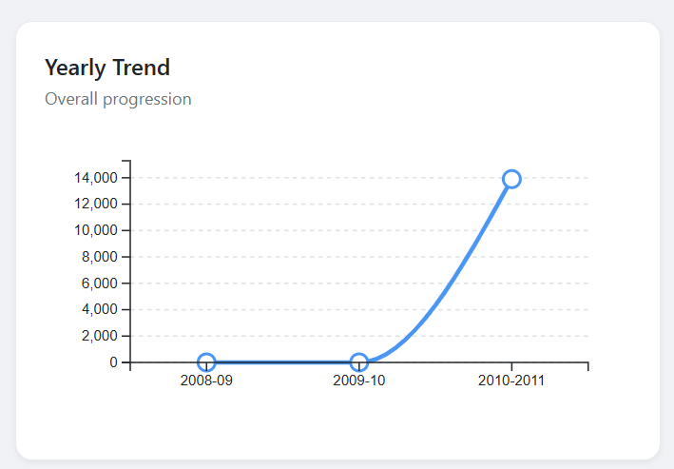

* 1. **Observations:**
     + **Steep Increase in 2010-2011**: The most notable trend is a dramatic surge in forest area change between 2010 and 2011. This suggests a significant shift in forest cover dynamics during this period, potentially due to factors such as policy changes, economic conditions, or natural events.
     + **Low Levels in Earlier Years**: Prior to 2010-2011, the forest area change remained relatively low and stable, indicating a period of minimal net forest conversion. This could be attributed to various factors, including sustainable forest management practices, economic constraints, or historical land use patterns.
     + **Lack of Data for Recent Years**: The chart does not provide data beyond 2010-2011. To gain a more comprehensive understanding of the

long-term trend, it would be valuable to have data for subsequent years to observe if the increase in forest area change has continued or reversed.

1. **Top Performing States:**
   1. **Chart:**

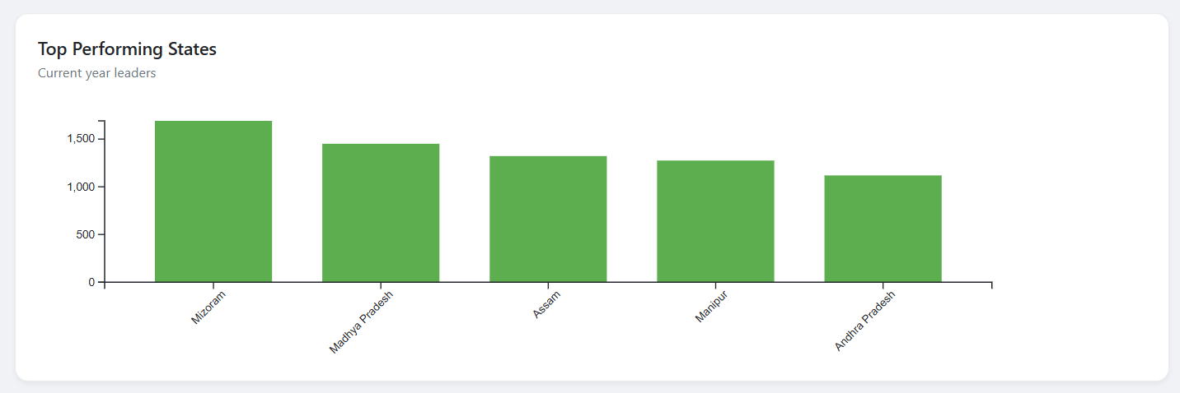

* 1. **Observations:**
     + **Mizoram Leads the Way**: Mizoram stands out as the top-performing state, with a significantly higher value compared to the others. This suggests that Mizoram has achieved a notable level of performance in the area being measured, potentially indicating strong policies, effective implementation, or favorable conditions.
     + **Close Competition:** Madhya Pradesh, Assam, Manipur, and Andhra Pradesh follow Mizoram, with relatively similar values. This suggests a competitive landscape where these states are performing at comparable levels, potentially showcasing different approaches or strategies to achieve success.
     + **Differentiation**: While the top five states are clustered together, there are slight variations in their performance. This indicates that even among the leading states, there are nuances and distinctions in their achievements, which could be attributed to specific factors such as geographic location, economic conditions, or governance structures.

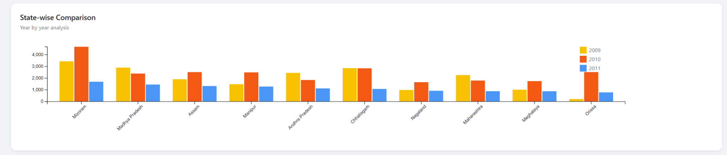

1. **Observations**:
   * **Mixed Performance Across States**: The chart reveals a mixed performance across the states, with some showing increases, decreases, or relatively stable levels of forest area change between 2009 and 2011. This indicates diverse trends and varying impacts on forest cover in different regions.
   * **Notable Increases**: States like Arunachal Pradesh, Mizoram, and Nagaland experienced significant increases in forest area change between 2009 and 2011. This suggests successful reforestation efforts, policy interventions, or favorable conditions in these regions.
   * **Decreases in Some States**: States like Assam, Manipur, and Tripura witnessed decreases in forest area change during the same period. This could be attributed to factors such as deforestation, land-use changes, or economic pressures.
   * **Year-to-Year Fluctuations**: Some states exhibit fluctuations in forest area change between the years, indicating dynamic trends and potential influences from various factors, such as economic conditions, climate variations, or policy shifts.

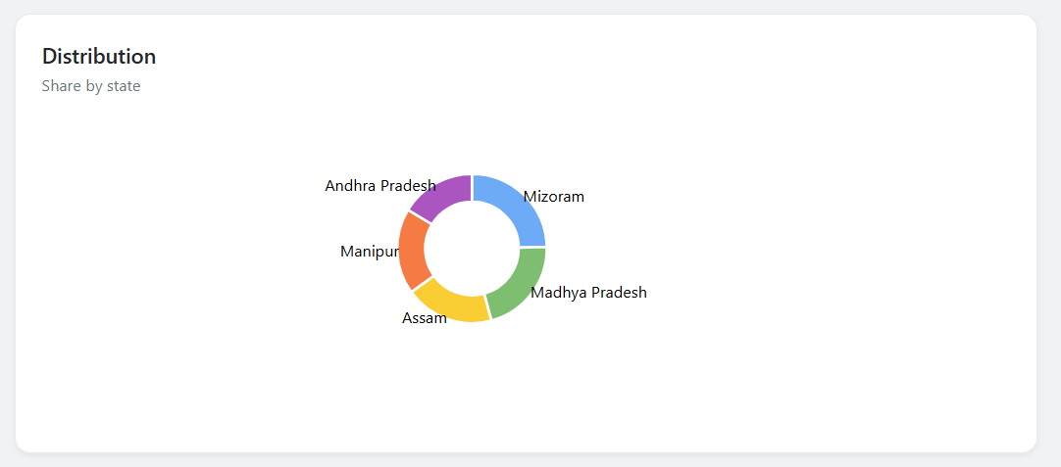

1. **Observations**:
   * **Dominance of Andhra Pradesh:** Andhra Pradesh occupies the largest portion of the pie chart, indicating that it has the highest share or contribution to the overall distribution. This suggests that Andhra Pradesh plays a significant role in the phenomenon being measured.
   * **Moderate Shares:** Mizoram, Manipur, Madhya Pradesh, and Assam have moderate shares of the distribution, suggesting that they contribute to the overall picture but to a lesser extent than Andhra Pradesh.
   * **No Dominant State:** The chart does not show a single dominant state, as all five states have a noticeable presence. This indicates a relatively balanced distribution among the states.

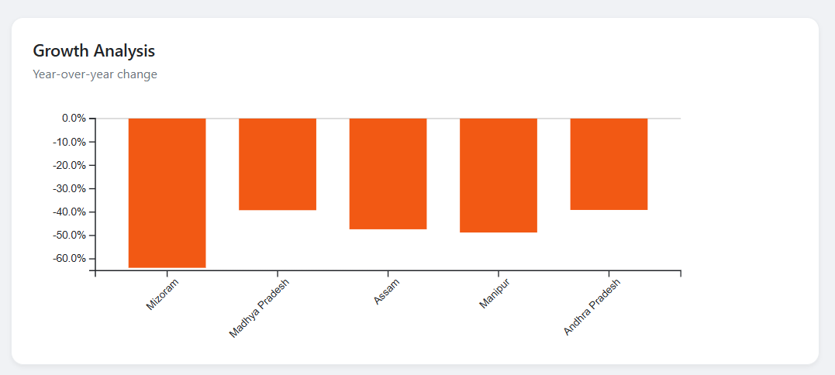

1. **Observations**:
   * **Negative Growth Across All States:** The chart indicates negative year-over-year growth for all five states, suggesting a decline in the measured variable (potentially forest area change) across the board.
   * **Varying Degrees of Decline:** While all states experienced negative growth, the magnitude of the decline varies. Mizoram and Manipur show the most significant decreases, followed by Assam and Andhra Pradesh, with Madhya Pradesh exhibiting the least decline.
   * **Consistent Trend:** The consistent negative trend across all states suggests a common underlying factor or set of factors influencing the decline in the measured variable.

**Dashboard:**

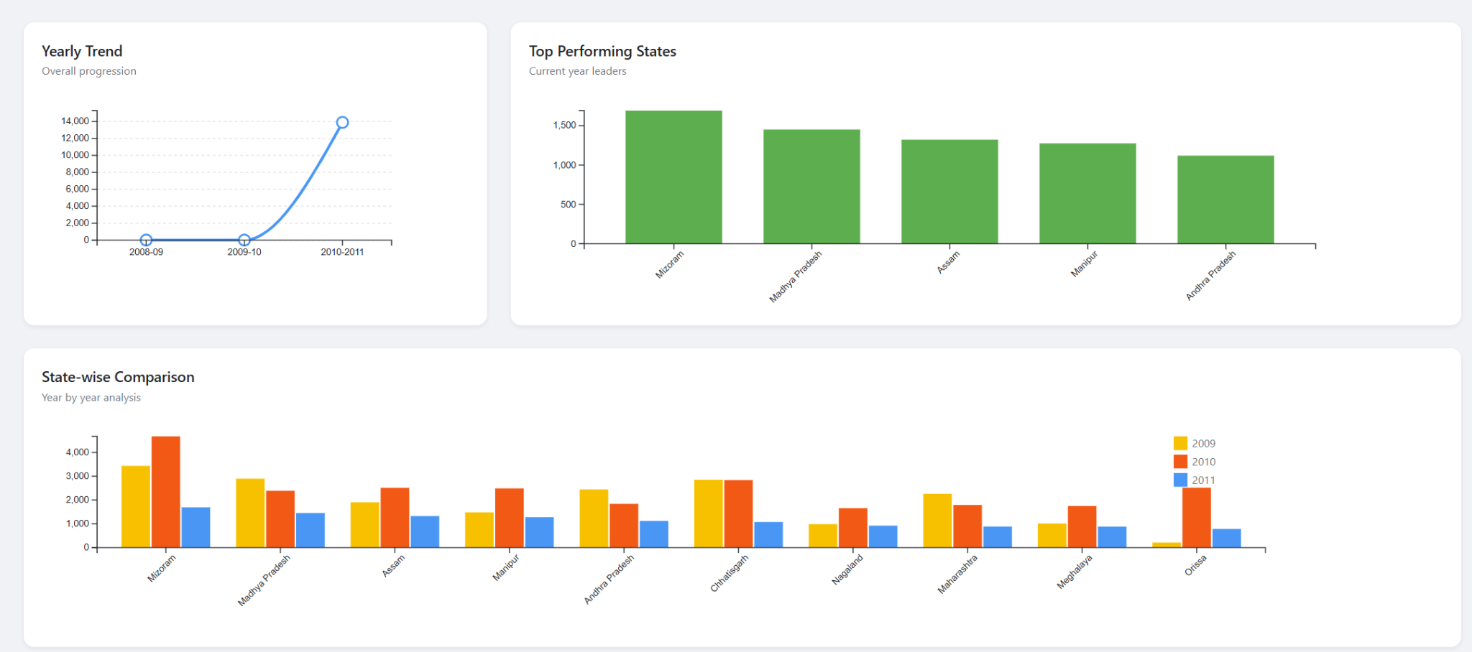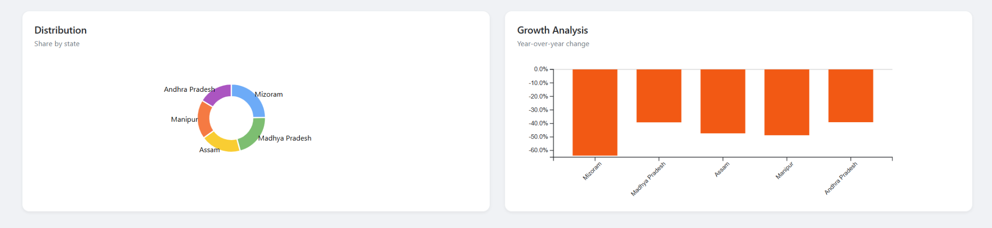

**Conclusion:**

From this experiment, I learned about the significant variations in forest cover changes across different countries over time, as well as how to effectively visualize and analyze such data using D3.js. By exploring the dataset, I was able to identify trends of deforestation and afforestation globally, and the importance of understanding net forest conversion for environmental sustainability. Additionally, integrating multiple charts, including line plots, bar charts, and scatter plots, provided deeper insights into the temporal and regional dynamics of forest areas, offering a clearer picture of global forest management efforts.